180401
Called Twofer with Double Bank
South Africa Oct 2017

This sequence shows a called twofer with a double bank between the hits. G and I were warming up by the fire outside our hut after a cold day of hunting when G spotted baboons on the upper field. After a strenuous stalk about 25y across the lawn we had a clear shot at 804 yards, 5 degrees up with light wind from the left. I told G that we needed something spectacular since the hunt was coming to an end.
He said "What! You don't think that my 60-odd correct wind calls out to 1800y were spectacular?"
I said "Well, of course they were but I mean something really spectacular... like a twofer, but we already had threefer in 2015 and D and R had a couple of twofers this year. So we need something better."
He said "Well, how 'bout a twofer with a bank between the bbns?"
"That's beginning so sound interesting" I said. "But why don't we go for a double bank shot?"
He agreed that would be fairly spectacular and thought about it a bit.
I asked if he thought he could call a double bank. He said "Hell yes, if you can shoot it."
So the gauntlet hit the ground. G worked up a twofer with a double bank.
He said "See the big one looking in our direction? When he stands take him just off the spine and a bit aft of the ribs. The bullet will pass through, assuming you don't screw up and hit the spine or a rib, bank off that little berm close to him, then bank of the next little berm a bit further on and then it will hit the small bbn above him."
I said I thought that was a bit of a cheeky call but I knew I could shoot it. Besides if I missed I could always blame his wind call. The shooter never makes a mistake; we always have a "bad wind call" to fall back on. So after a short conversation about "Are you ready?", "Of course I'm ready", etc. I took the shot.
Sure enough, it worked just like G had predicted as shown in the following photos.

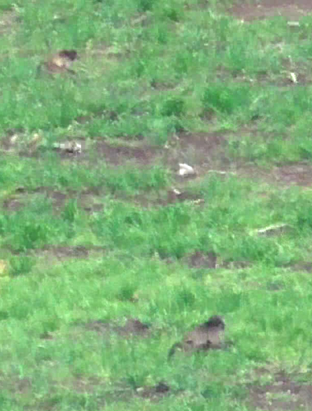
Large bbn below and small one (Mr. Unlucky) above just before the hit.

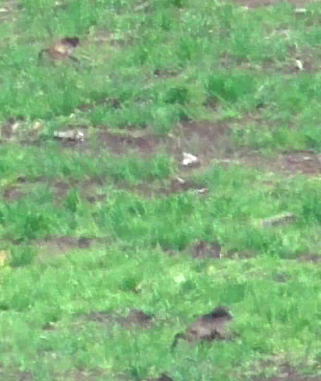
Hit on lower bbn, bullet passes through and hits the first bank shown by the puff of dust just above his rear end.

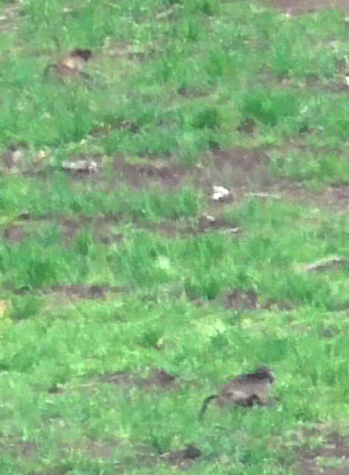
Second bank impact just above and to the left from the first one. Note the alignment between bbn 1, the two banks and bbn 2. You can see this is gonna work.

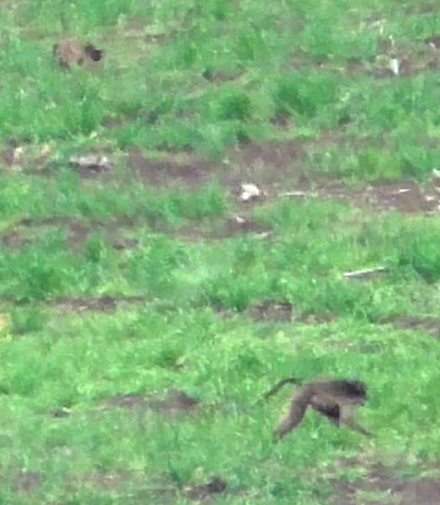
Bbn 2 has been hit and has faceplanted. Bbn 1 is in frenetic motion but his spine is severed.

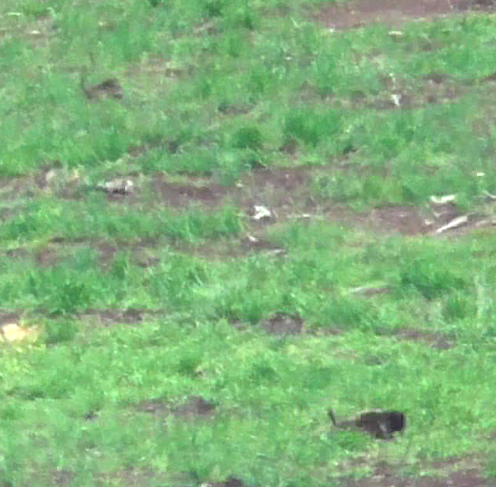
Bbn 1 is down and bbn 2 is beginning to recover after 428msec in FM. This illustrates why we usually avoid double bank shots; the banks absorb so much energy that the second bbn often runs away, mostly unharmed - but pissed off to be sure.

So, boys and girls, that's how the ISRUCBT (International Second Runner-Up Counter-Baboon Team) and WBWC (World's Best Wind Caller) got a called twofer with a double bank.

